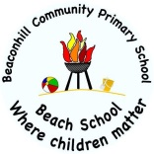
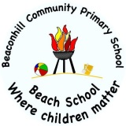
Beaconhill Primary School
Year Six Curriculum

 | Science | Art and Design | Computing | Design and Technology | Geography | History | Languages | Music | Physical Education | Religious Education | PSHE
Autumn | Animals, including humans  Living things and their habitats | Pop Art  Andy Warhol | Online Safety  Coding | Fajitas | Land Use in the UK: Coasts and Coastal Erosion | British 20th Century Popular culture | Numbers, Classroom commands,  Noun adj agreement | First Access – Recorders  How does music connect us with the past? | Multi-skills  Dance  Quad kids Athletics | Islam:  showing commitment to God  Christianity: Mary and Jesus | Being me in my world  Celebrating differences
Spring | Evolution and inheritance | Weaving and sculpture (Mayans)  Monet | Spreadsheets  Blogging | Weaving | Brazil: Rivers  (Geography) | Mayan Civilisation | Greetings, classroom items gender, adj agreement  Descriptions, Family, months. | How does music make the world a better place?  How does music teach us about our community? | Gymnastics  Hockey  Badminton | Christianity: Beliefs about eternity  Christianity: How strong is Christianity? | Dreams and Goals  Healthy me
Summer | Electricity  Light | Pattern and tessellation | Networks  Quizzing | Fairgrounds |  | Early Islamic Civilisation | Geography, sentence formation, a town, directions, contraction.  Etre, adjective agreement, avoir, numbers. | How does music shape our way of life?  How does music connect us with the environment? | Tag Rugby  Kwik-Cricket  Swimming | Islam:  Life after death? | Relationships  Changing me

