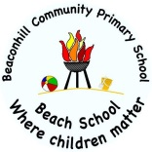
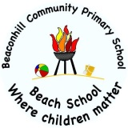
Beaconhill Primary School
Year Six Curriculum

 | Science | Art and Design | Computing | Design and Technology | Geography | History | Languages | Music | Physical Education | Religious Education | PSHE
Autumn | Animals, including humans  Living things and their habitats | Pop Art  Andy Warhol | Online Safety  Coding |  | Land Use in the UK: Coasts and Coastal Erosion | British 20th Century Popular culture | Numbers, Classroom commands,  Noun adj agreement | Dancing in the Street – Motown  First Access - Recorders | Multi-skills  Dance – 50s  Quad kids Athletics | Islam:  showing commitment to God  Christianity: Mary and Jesus | Being me in my world  Celebrating differences
Spring | Evolution and inheritance | Weaving and sculpture (Mayans)  Monet | Spreadsheets  Blogging |  | Brazil: Rivers  (Geography) | Mayan Civilisation | Greetings, classroom items gender, adj agreement  Descriptions, Family, months. | History of music - Classical  Pop  Happy | Basketball  Hockey  Badminton | Christianity: Beliefs about eternity  Christianity: How strong is Christianity? | Dreams and Goals  Healthy me
Summer | Electricity  Light | Pattern and tessellation | Networks  Quizzing | Fajitas  Fairgrounds |  | Early Islamic Civilisation | Geography, sentence formation, a town, directions, contraction.  Etre, adjective agreement, avoir, numbers. | Hiphop  Fresh Prince of Bel Air  Year 6 show | Tag Rugby  Kwik-Cricket  Outdoor Education (Residential) | Islam:  Life after death? | Relationships  Changing me

